TO – DO LIST

1.Task ezhuthuka

2.Cheyyth kazhijal delete cheyyuka

3Typing box

4.Add button

5.Add cheyyumbo thazekk list aayitt varanam

6.Then ath delete cheyyanulla option um

7.Cheyyth kazhijal tick mark

Ivide design already set aakki vachind

Git hub link 🡪 src 🡪

Css 🡪 <https://github.com/Packapeer/React_tutorial_todo_App/blob/main/src/App.css>

Jsx 🡪 <https://github.com/Packapeer/React_tutorial_todo_App/blob/main/src/App.js>

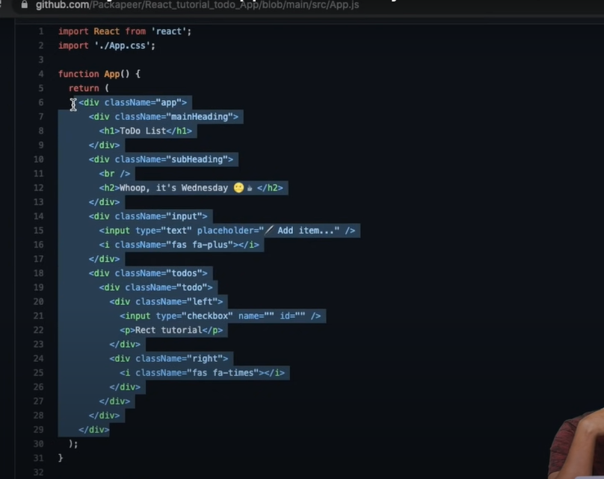

Return eduthu named app.js il vakkunnu (jsx copy cheyyth idunnu)

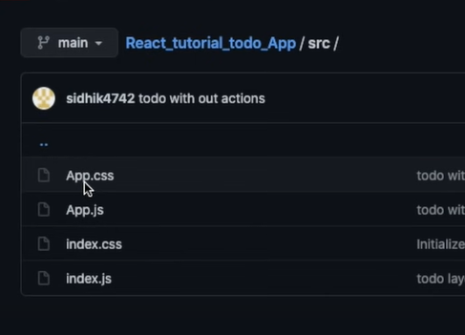

Css full copy cheyyth named app.css il iduka

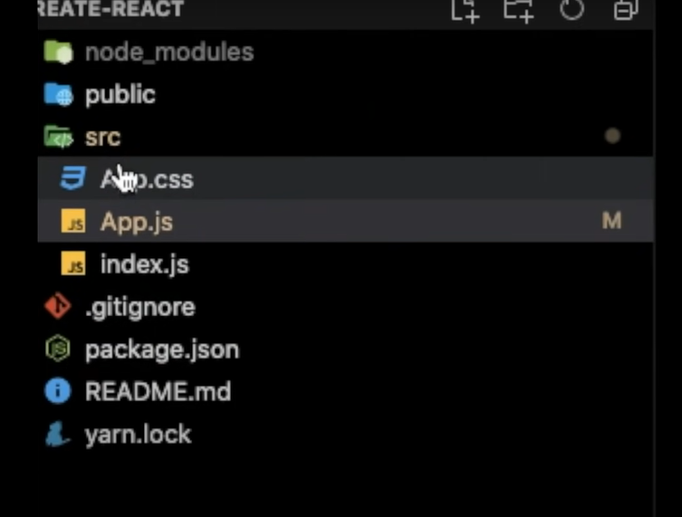

node -v 🡪 **Check Node.js Installation**:

npm -v 🡪 **Check npm Installation**:

npm install -g create-react-app 🡪 install the **create-react-app** package:

npx create-react-app my-react-app 🡪 Replace **my-react-app** with the desired name of your React application.

cd my-react-app 🡪

npm start 🡪This command starts the development server and opens your new React application in a web browser. Any changes you make to your React code will be automatically reflected in the browser.

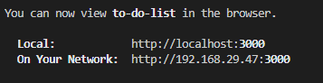

C:\Users\MALEKANDATHIL\Desktop\to-do-list\to-do-list> npm start 🡪 for running

Ctrl + ` 🡪 for get terminal

Buttons ellam eduthath **font awsome** library nn aanu

So athinte cdn add cheyyanam

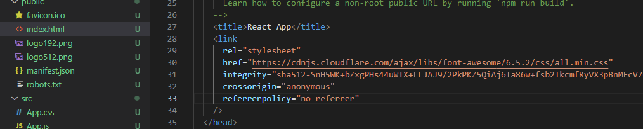

Index.html il aanu link kodukkendath

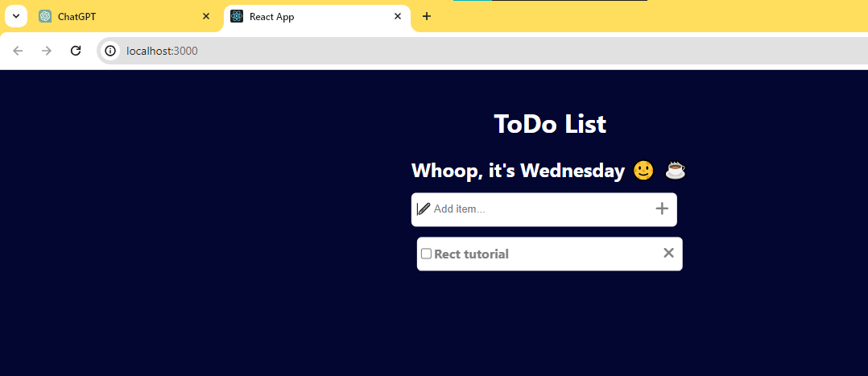

Add button and delete button ui varunnu

Ini ithinellam action kodukkanam

Ella buttonum action kodukkanam

Data store cheyyth action kodukkanam

So state manage aanu ivide vendath

So 1st use state import cheyyuka

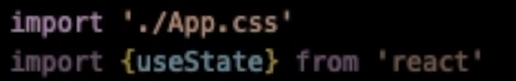

Oro state ilum nammal oro todos array aayi eduthu vakkunnu

Array de ullil oro to-do eduthu vakkunnu

Oru array nte ullil multiple todos

Because todos ivide oru list aanu.

Default aayitt empty arrary kodukkunnu

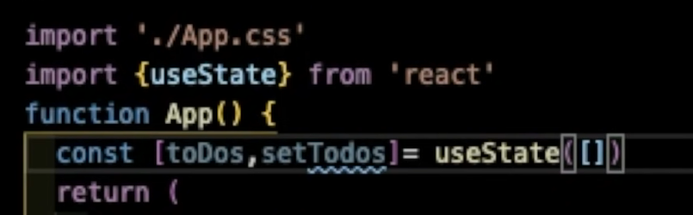

Then todo enna state create cheyyuka for store each letter while typing

Default aayii empty string kodukkunnu

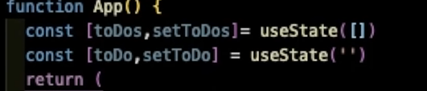

Validation okke vendi ith use cheyyunnu

toDo enna value kanikkanam

onchange il arrow function nte ullil settodo koduthh last vanna data edukkum

arrow function il event kodukkunnu

short aayi e enn ezhuthunnnu

e.target.value vach type cheyyana value kittunnu

ath settodo nte ullil kodukkum

ath todo state nte ullil kerum

then aah todo display aayi kond irikkum

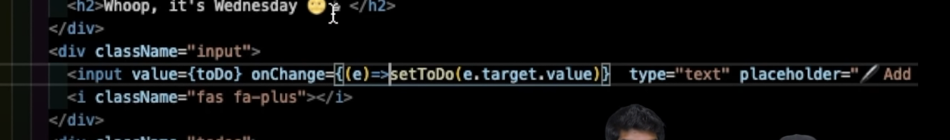

Plus press cheyyumbo ee todo eduth todos il idanam

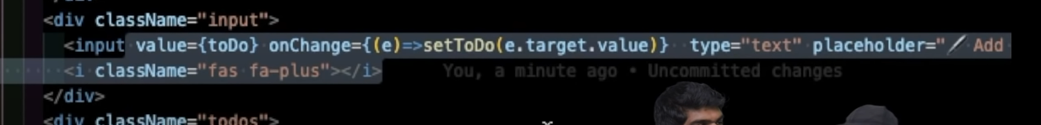

Form aangil name vach edukkam

Allagil ingne aanu cheyyuka.ithanu react method

Multiple inputs undagil vere method und

Plus button nte avide settodo vach todo pass cheyyanam

Ithoru array aanu .array lekk idan ota method ullu.

So athinu push use cheyyunnu

But push ivide cheyyan patilla

setTodos vach todos ne update cheyyanam

so ivide **spread**  operator use cheyyanam

settodos nte ullil oru array koduth athinte ullil todos … spread cheyyunnu + ippo ulla todo pass cheyyunnu



Todos ne spread aakiyal ath orooro values aayii maari

Last ota array aavunnu

Todos nte ullil 3 values undagil athine 3 um ota array aaki maatum

Then todo athilekk athinte baaki aayi add cheyyth ota array aakum

Then ath todo lekk vakkum

Ippo plus button press cheyythal add aayittundavum

Then ini todo list cheyyanam thazhe

So athinu map use cheyyanam

Todos nte array vach map ezhutham

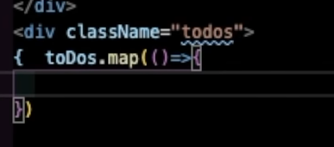

Basic structure

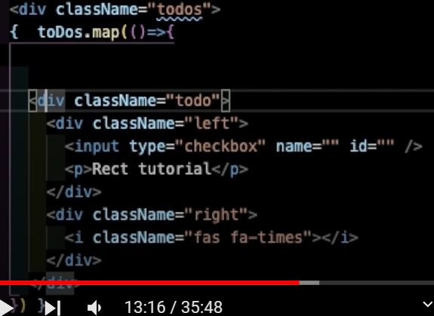

Div ullilekk idanam

Return kodukkanam

Ota component mathre return cheyyan patullu

String aayittanu values varunnath

Map call cheyyumbo oro arrayed oro position ulla values value ennathilekk varunnu

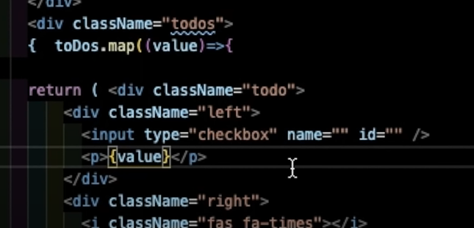

Then ini refresh aavumbo

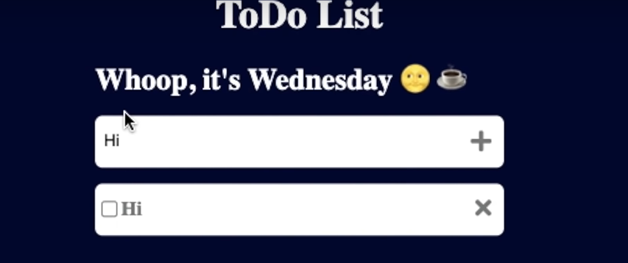ini run cheyyumbo values varunnu

Then ini checkbox update cheyyanam with true or false

Nammal string aanu pass cheyyunnath

Ath maati oru object aakanam🡪 value and status

So todo object aayii pass cheyyanam

Status default aayi false kodukkunnu

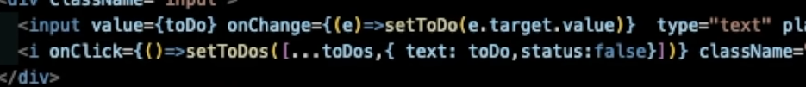

Todo text lekk store cheyyth vakkunnu

So mape nte ullil value oru object aanu

So dot vach access cheyyanam

Checkbox nu status kodukkanam

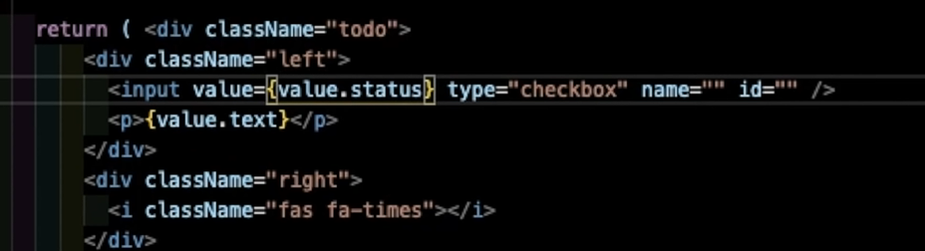

Then run cheyyuka

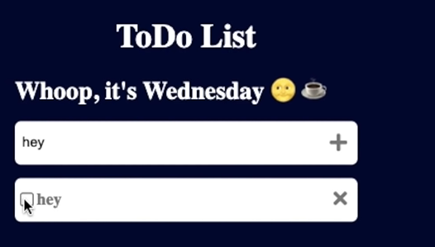

**Tick idumbo action kodukkanam**

Multiple list varunnu

So oro value num id kodukkanam

Ivide date ne id aakkii edukkunnu

Ivide date.now() function use cheyyunnu



Ippo ulla date and time ne id aaki kodukunnu

Aah id vach object ne get cheyyunnu

Then aah object nte status change cheyyuka

Value maati obj aakkunnu

Tick kodukumbol varunna changes console cheyth nokkunnu

e.target.value 🡪 checkbox il ulla value

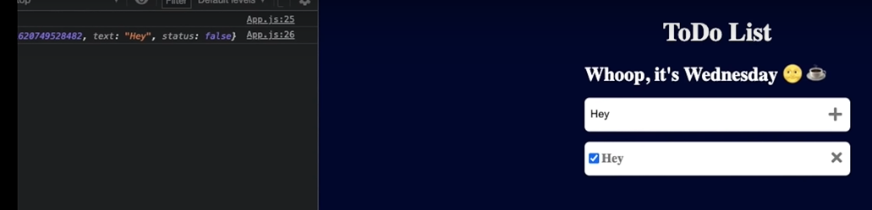

Running

Click cheyyumbo status true aakanm



Ithanu object

setTodos todos filter cheyyth new array kittan kodukkunnu

obj2 il new value varum

obj2 and obj id same aangil condition ezhuthuka

then obj2 return cheyyuka

oru new array aayi aavshym ullath mathrm return cheyyam

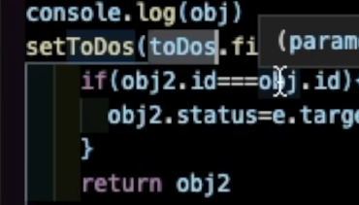

Todos nte aah positionlekk thanne return cheyyum

Then avide replace nadakkum

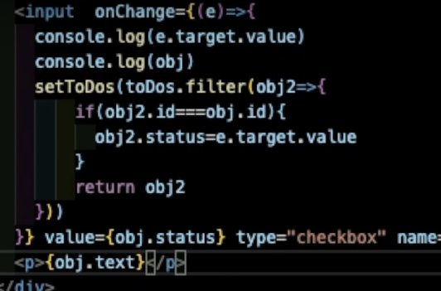

Active task enna oru component right sidil varanam

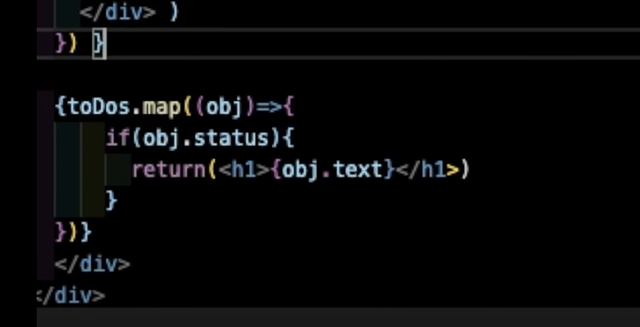

True aayath vere varunnu

Mapil return kodukkanam

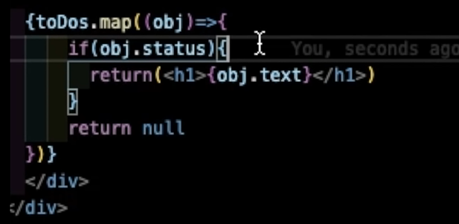

Mapil default aayi enthkilum return cheyyanam

Ivide null return cheyyunnu

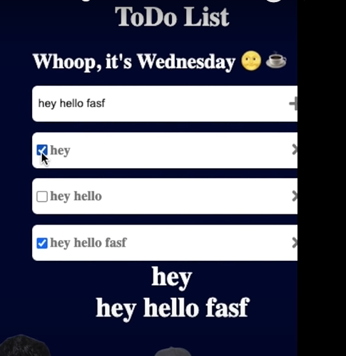

Running

**Untick cheyyumbo ath povunnilla**

Ath maatanam

Tick cheyumbo false aanu eppolum varunnath

True varunnilla

Checkbox aayth kodn checked nn kodutha mathii

So angne ayal Boolean pass cheyyum

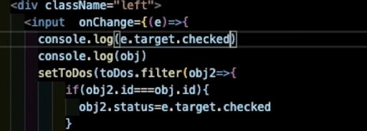

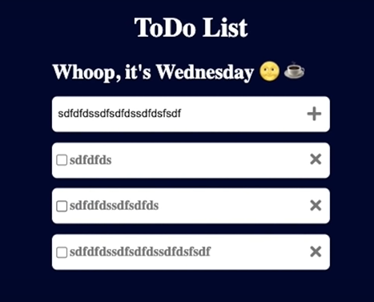

Now untick cheyyumbo disappear aavunnu

**Delete cheyyan**

Filter cheyyuka 🡪 same id aangil 🡪 delte cheyyuka

Tick mark idumbo vet

Time and date display

Active todos eath ?

Kazhija todo eath ?

Kazhijitt remove cheyyuka.

**ACTIVE , COMPLETED ,2 ilum remove option**